Photoactivatable gel interfaces for mechanobiological studies of collective cell migration

S. Yamamoto,¹⁾ Kazuo Yamaguchi,²⁾ and Jun Nakanishi^{1)*}
¹⁾WPI Center for Materials Nanoarchitectonics (MANA), National Institute for Materials Science (NIMS)
²⁾Faculty of Science, Kanagawa University

Title: Times New Roman 14p. Centering, Bold
Name: Times New Roman 12p. Centering, Bold
Affiliation: Times New Roman 11p.
Contents: Times New Roman 11p.
Figure caption: Times New Roman 9p.
References: Times New Roman 10p.
Space between the lines: one
Please put at least one figure!
One page! (Delete this box on submission)
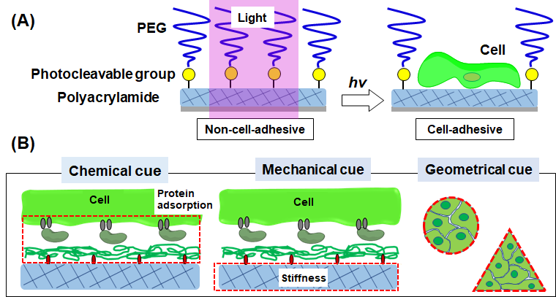
Collective migration is the mechanobiological interplay within migrating cell clusters and against underneath extracellular matrices (ECMs), mediating various physiological and pathological processes. Therefore, it is crucial to develop a robust platform, where collective migration can be studied in standardized conditions, to understand how cells migrate differently between normal and disease states.¹⁾ Here, we developed photoactivatable hydrogel interfaces as a suitable platform for such applications.²⁾ The substrate was composed of poly(acrylamide) (PAAm) hydrogel, whose surface was sequentially functionalized with poly-D-lysine (PDL) and photocleavable poly(ethylene glycol) (PEG). On the surface of the gel substrates, cell clusters with any given geometries can be prepared by controlling the irradiation patterns (geometrical cue), and their collective migration can be induced by the following irradiation of the surrounding regions. Moreover, the substrate mechanical property can be controlled by changing the composition of the PAAm hydrogel (mechanical cue), and the chemical properties were controlled by changing the amount of immobilized PDL, thereby altering the adsorption amount of ECM proteins (chemical cue). The surface characteristics of the photoactivatable gel substrates were several physicochemical methods and protein adsorption test. Some of the proof-of-concept experiments were shown, which highlighted the interplay of chemical, mechanical, and geometrical cues in the regulation of various collective characteristics, including migration rate, epithelial phenotype, and drug response. We believe the present platform will be a useful research tool for comprehensive mechanobiological analysis of collective cell migration.
Fig. 1. Research strategy. (A) Schematic presentation of a photoactivatable gel interface and (B) independent control of chemical, mechanical, and geometrical cues.

[References]
- J. Nakanishi,* "Photoactivatable Substrates: A Material-based Approach for Dissecting Cell Migration" Chem. Rec. 17: 611-621 (2017).
- S. Yamamoto, K. Okada, N. Sasaki, A. C. Chang, K. Yamaguchi and J. Nakanishi,* Submitted.

