

**N**ational **I**nstitute for **M**aterials **S**cience

Sengen 1-2-1, Tsukuba, Ibaraki 305-0047, JAPAN Tel: (81)29-859-2751

14th May 2025

Dr. Shigeki Kawai

1-2-1, Tsukuba, National Institute for Materials Science

Ibaraki, 305-0047, Japan

# Letter of Invitation

Dear Dr. Shigeki Kawai:

We are delighted to invite you to participate in the 26th International Conference on Non-contact Atomic Force Microscopy, taking place in Toyama, Japan, August 3-8, 2025, and to present an Oral/Poster about your recent excellent work.

This conference is part of a series of international conferences devoted to the latest progress in dynamical atomic force microscopy. It covers experimental, theoretical, and instrumental developments in frequency modulation and other dynamic operation modes with particular emphasis on aspects of high-resolution imaging and force spectroscopy.

Please note that following the tradition of previous conferences in this series, the conference does not extend any financial support to speakers to cover items such as their travel, accommodation, or registration fee. You can find the registration page for our conference at the following web address:

<https://www.nims.go.jp/group/Nanoprobe/NC-AFM2025/Index.html>

Sincerely,

署名/Signature

Shigeki KAWAI, Conference Chair of NC-AFM 2025

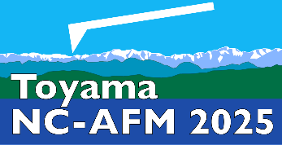Assoc. Prof. Dr, Group Leader

Nanoprobe Group, Center for Basic Research on Materials,

National Institute for Materials Science (NIMS)

KAWAI.Shigeki@nims.go.jp