This is the Template for Speakers at EIC 2017
(18-Point Font, Centred and Bold, Times New Roman)

A.Author¹, B. Author², C. Author³
(list of authors in 12-point font, centred and bold, Times New Roman: underlined the corresponding author)
1- The author affiliation and full address should be located here in 11 point font, centred and in italics
2- Address of author2 if different
3- Address of author3 if different

Corresponding author email address: in 11 point font, centred and in italics

The abstract must be written in English. It is very important to ensure that the style guide presented in this template should be followed in order to provide a uniform and consistent appearance. Abstract should be in 1 page of A4 size paper (20.99 cm x 29.70 cm) and camera-ready format (Margins of Top, Bottom, and Sides: 25 mm each). The text should be written with single line spacing using a font of 12 pt Times New Roman. A couple of Figures/Tables may be included.
In the main body of the text, the reference designation should be with square brackets as [1], [2, 3] and [1-3].
Your abstract and CV for invited speakers will be provided to the attendants as a book of abstracts at the start of the conference. The prepared abstract in WORD and PDF format should be submitted to the E-Mail: EIC2017@nims.go.jp.

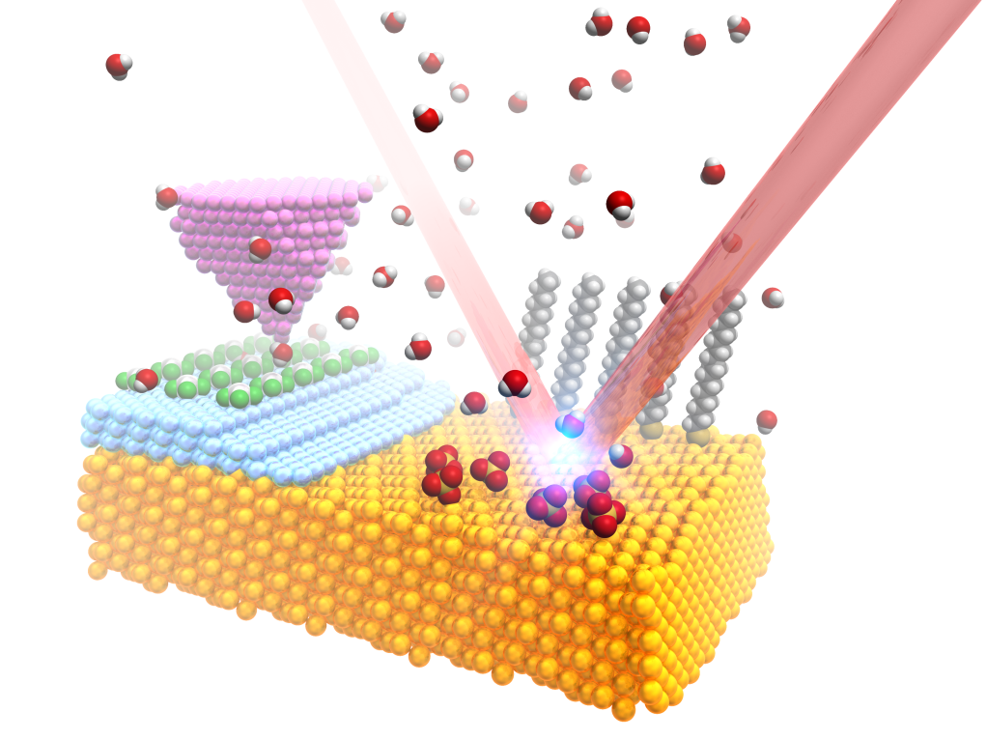
Fig. 1. Logo of EIC2017.
Table 1. Summary of abstract format.

Margins (top, bottom, and sides) | 25 mm each
Font | Times New Roman
Title | 18-pt, Bold
Author names | 12-pt, Bold
Affiliations | 12-pt, Italic
Corresponding author’s email address | 12-pt, Italic
Body text | 12-pt
Figure and table captions | 12-pt
References | 12-pt

References
[1] A. Author1 and A. Author2, Journal Name, vol., start-page (year).
[2] A. Author1, B. Author2, C. Author3, Journal Name, vol., start-page (year).
[3] A. Author1, Title of book (Publisher), Chapter or start-page, (year).

